Amar Kruja and Ermi Xhaferi

BR_TM_01 - View and Search Tour Packages
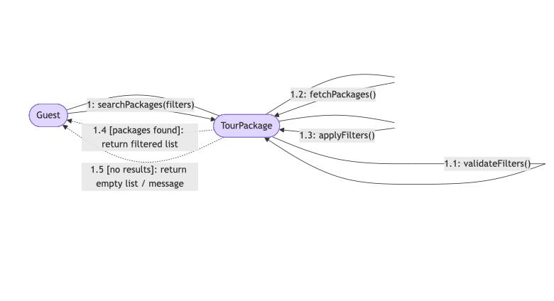

BR_TM_02 - Create Account and Login
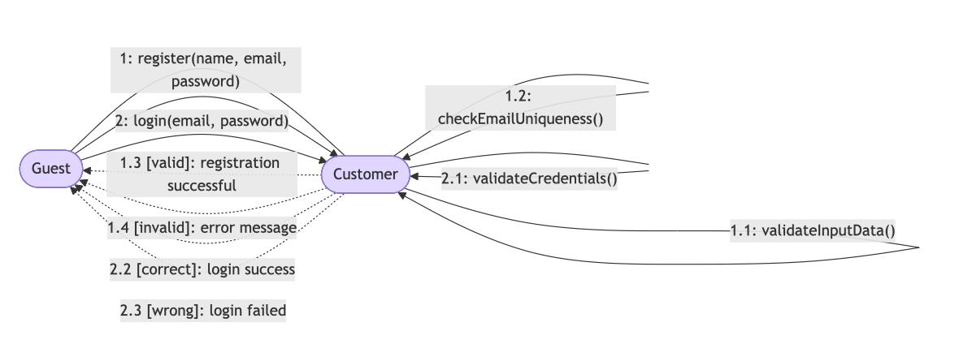

BR_TM_03 - Search and Filter Tour Packages
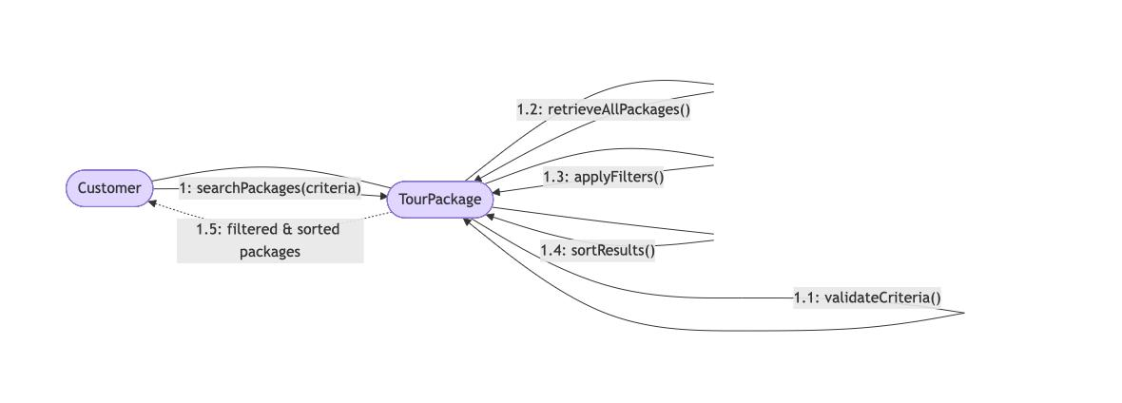

BR_TM_04 - View Tour Details
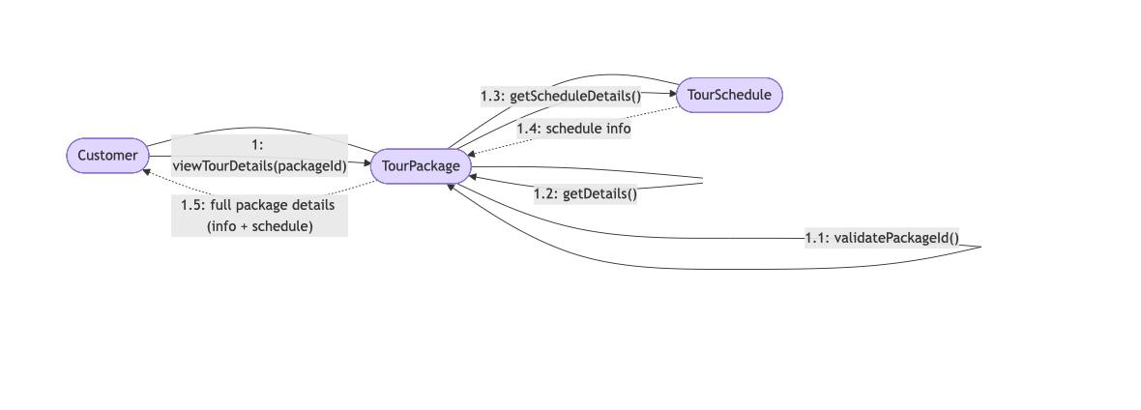

BR_TM_05 - Book Tour Package
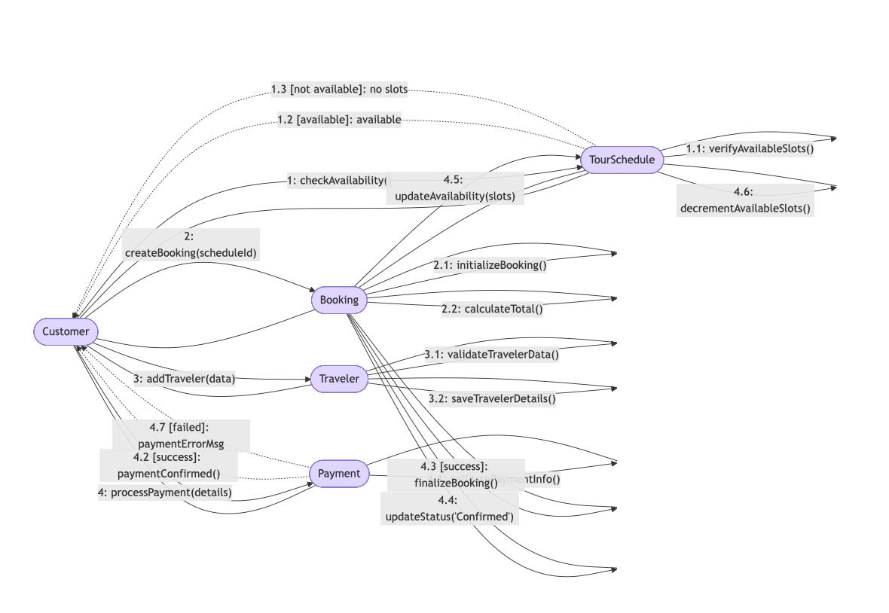

Alisa Dhima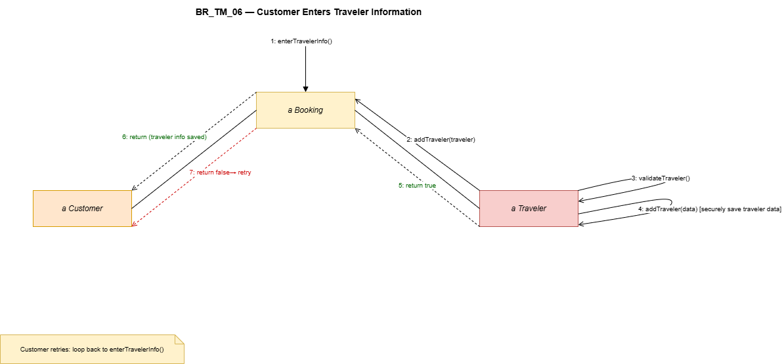

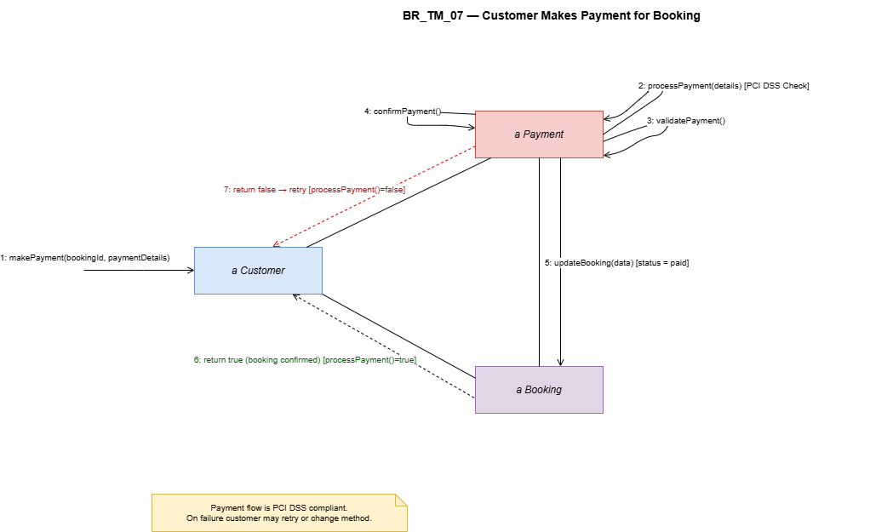

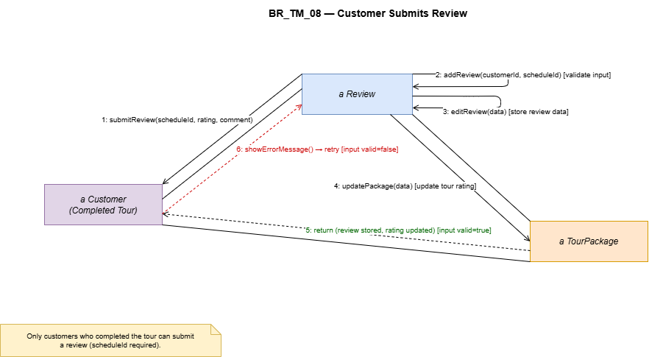

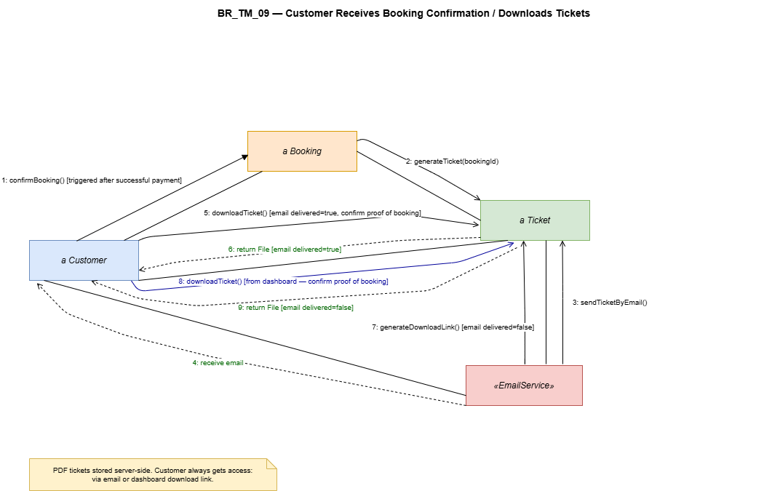

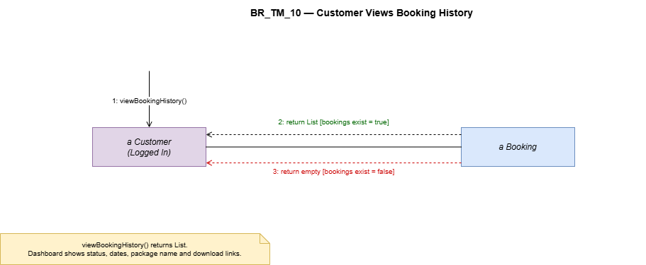

Amanda Stafasani

BR_TM_11 — Customer cancels a booking
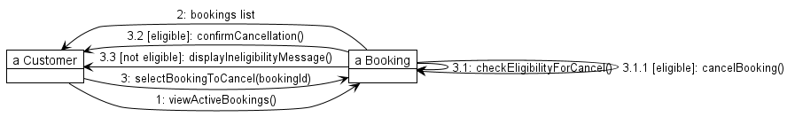

BR_TM_12 — Customer updates personal profile
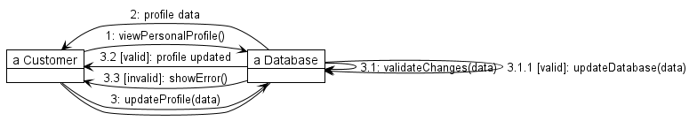

BR_TM_13 — Booking agent creates a booking for a customer
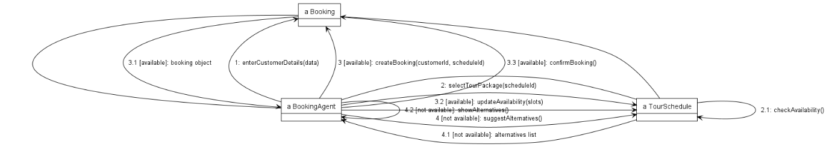

BR_TM_14 — Booking agent updates or cancels a reservation
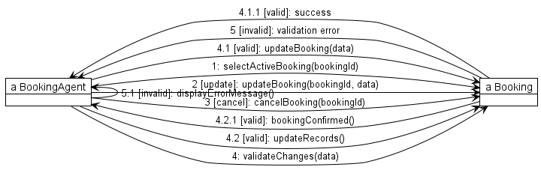

BR_TM_15 — Booking agent checks travel package availability
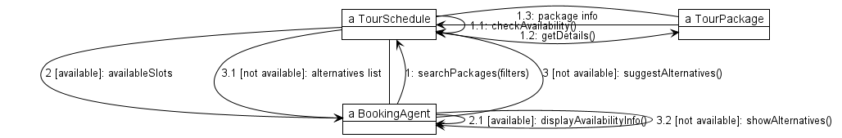

Lumturi Bedalli

BR_TM_16 – Agent Views Customer Travel History
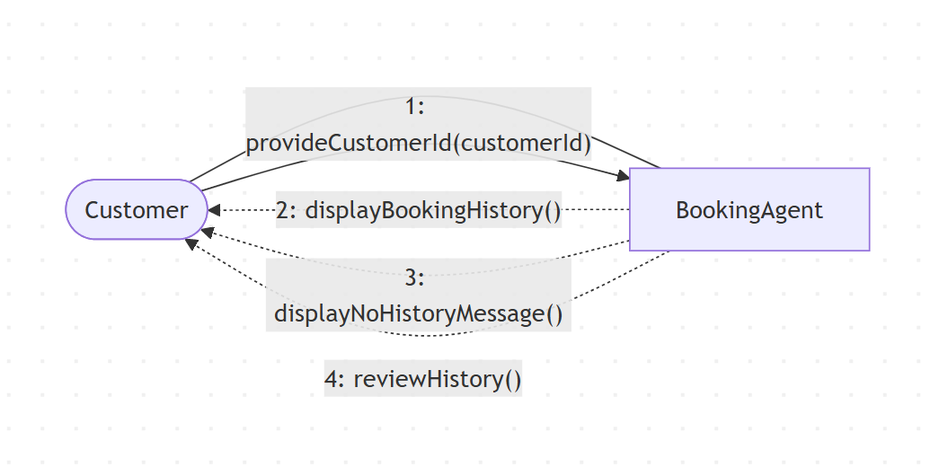

BR_TM_17 – Modify Existing Booking
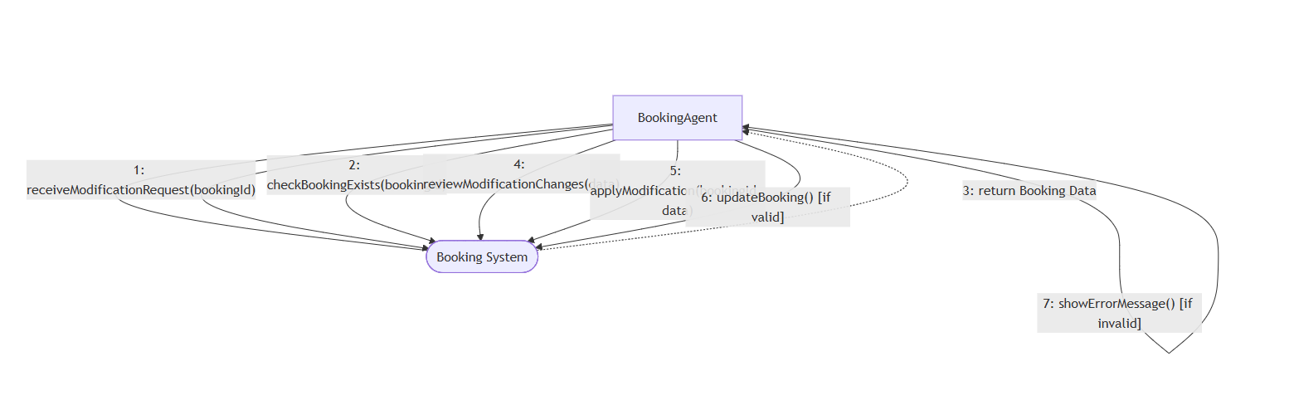

BR_TM_18 – Reply to Customer Reviews
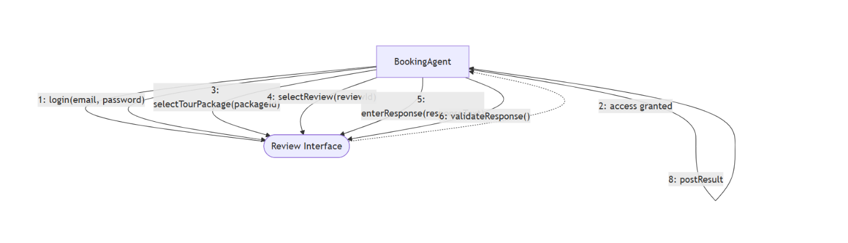

BR_TM_19 – Verify Customer Payments
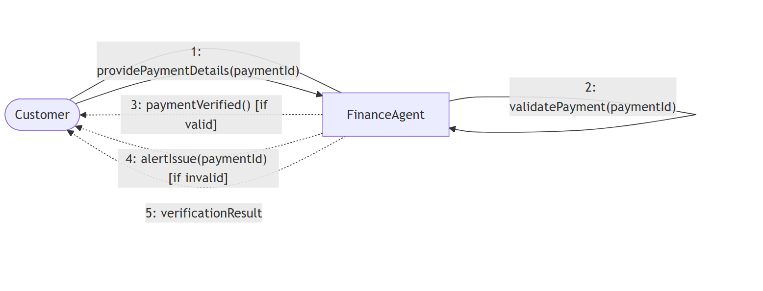

Henri Shehu

BR_TM_20
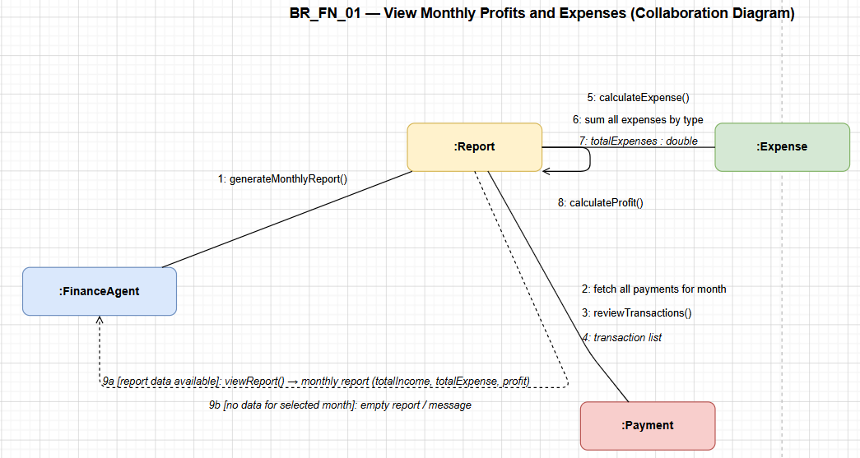

BR_TM_21
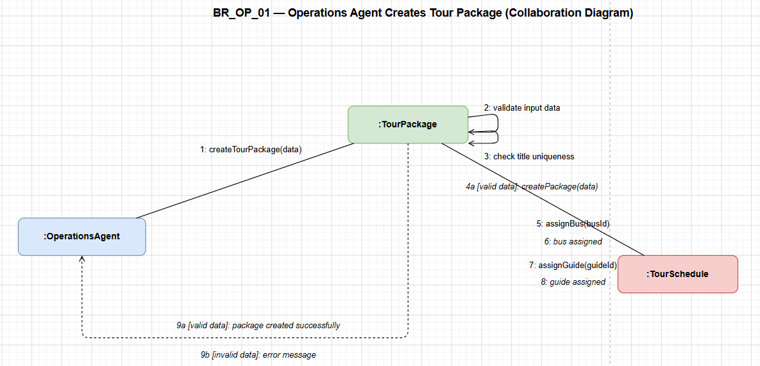

BR_TM_22
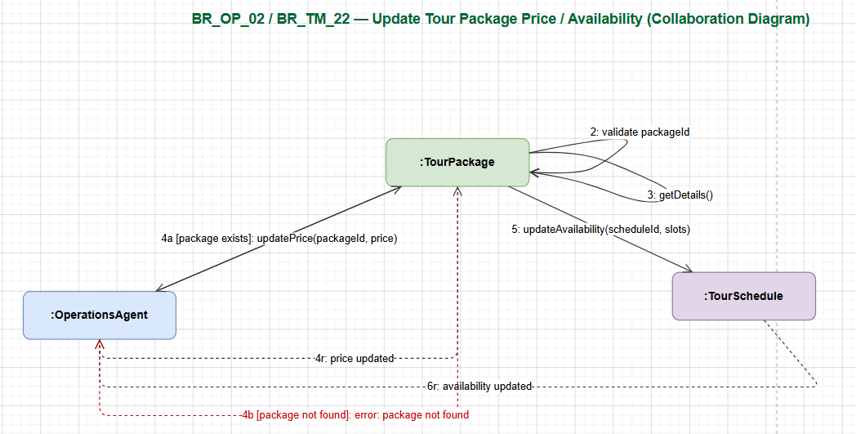

BR_TM_23
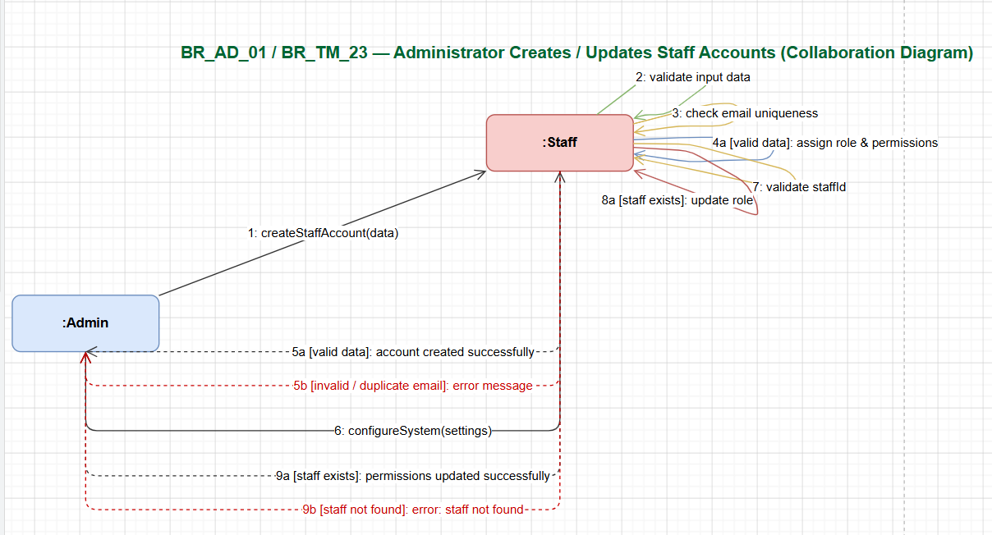

Enian Xhixha

BR-TM-24
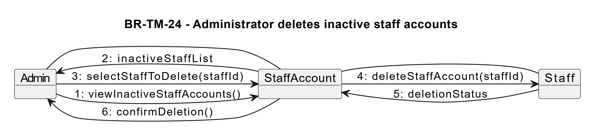

BR-TM-25
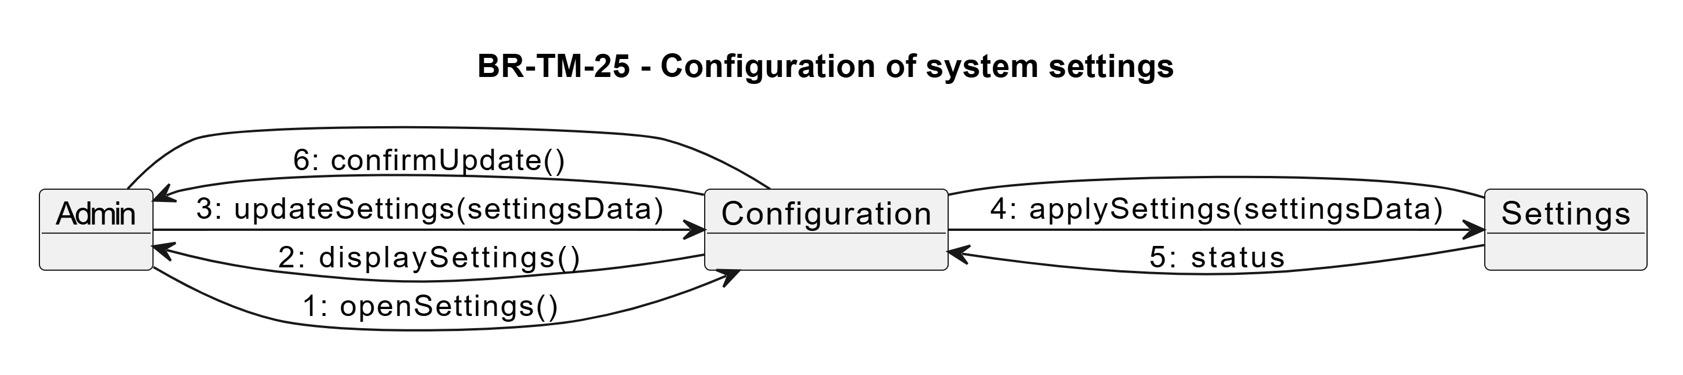

BR-TM-26

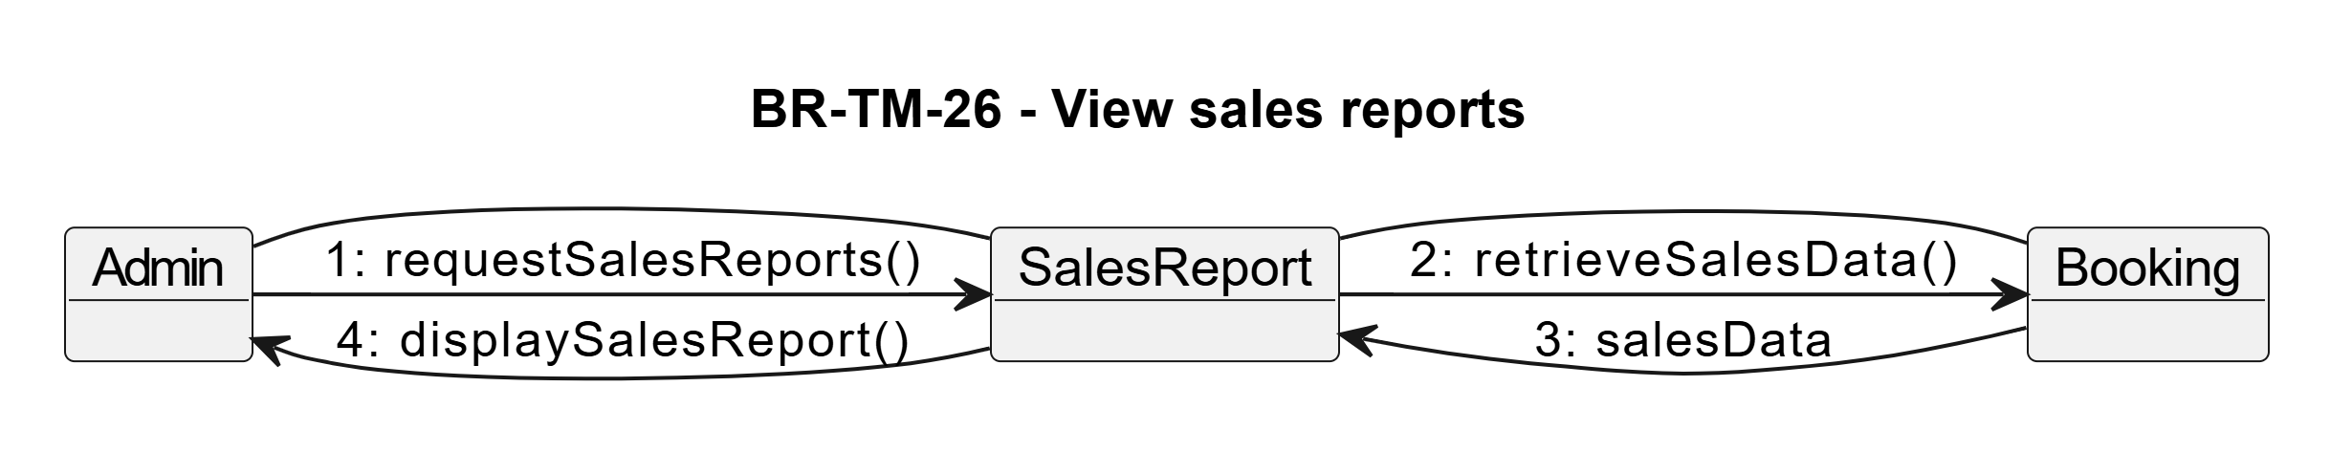

BR-TM-27
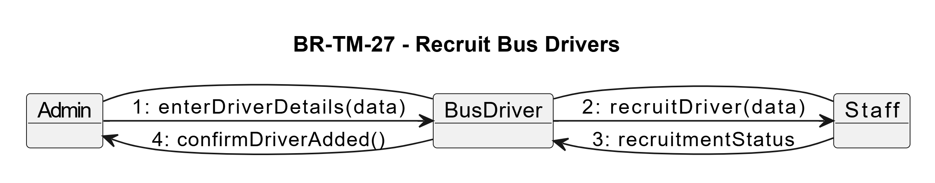

BR-TM-28
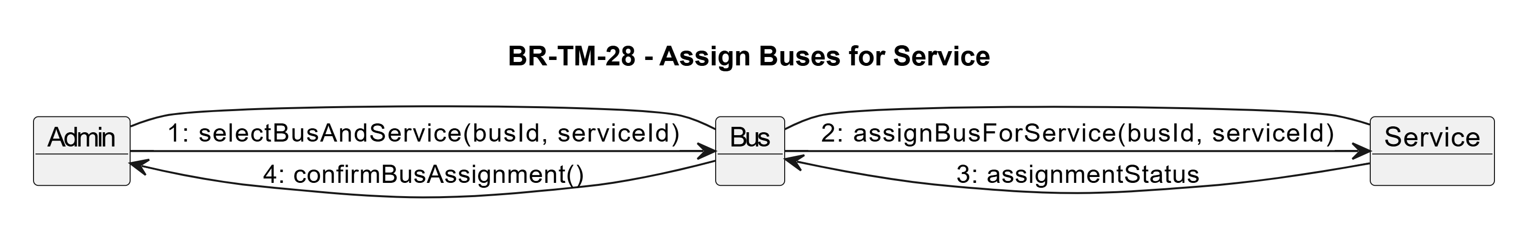

Era Selmanaj

BR_TM_29 – Register number of buses
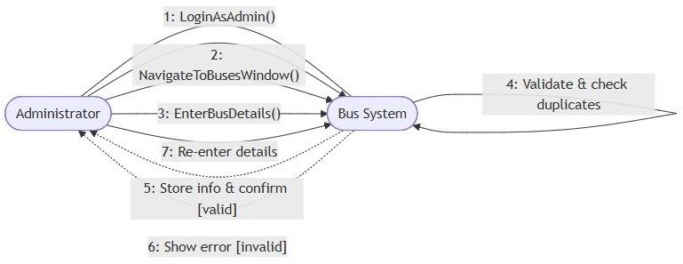

BR_TM_30 – Confirm Clients and Collect Payments
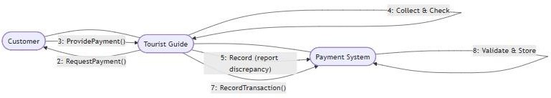

BR_TM_31 – Declare Collected Money

